
Company
Logotype

Cone Beam Computed Tomography- Report



Porur Dental X-rays & CBCT

Patient Name : Mr. Manikandan | Date of Report : 28.10.2025
Age/ Gender : 28 years/ Male | Region of Interest : CBCT TMJ
Referring doctor: Dr. Abinaya | Indication : Temporomandibular joint assessment
Clinical Notes: Nil
PATIENT INFORMATION

CBCT- Tomo provided
CBCT – IMAGE DETAILS

RADIOGRAPHIC INTERPRETATION

During rest position – Right Temporomandibular joint:
- In relation to the right temporomandibular joint, presence of mild degenerative changes in the superior surface of the head of the condyle causing mild flattening is evident.
- The condylar head lies within the glenoid fossa during rest position.

During rest position – Left Temporomandibular joint:
- In relation to the left temporomandibular joint, mild degenerative changes in the medial surface of the head of the condyle causing morphological alteration of the condylar head is evident.
- The condylar head lies within the glenoid fossa during rest position.

During open mouth position - Temporomandibular joint:
- In relation to the right and left temporomandibular joint, the head of the condyle appears to be placed out of the mandibular fossa and is present just below the articular eminence.

Mucosal thickening evident in relation to the floor of the right and left maxillary sinus.

RADIOGRAPHIC IMPRESSION

- Mild Internal derangement of Temporomandibular joint – Right and left side.
- Bilateral maxillary sinusitis.

Kindly correlate with clinical findings


IMAGES FOR REFERENCE

Coronal view:
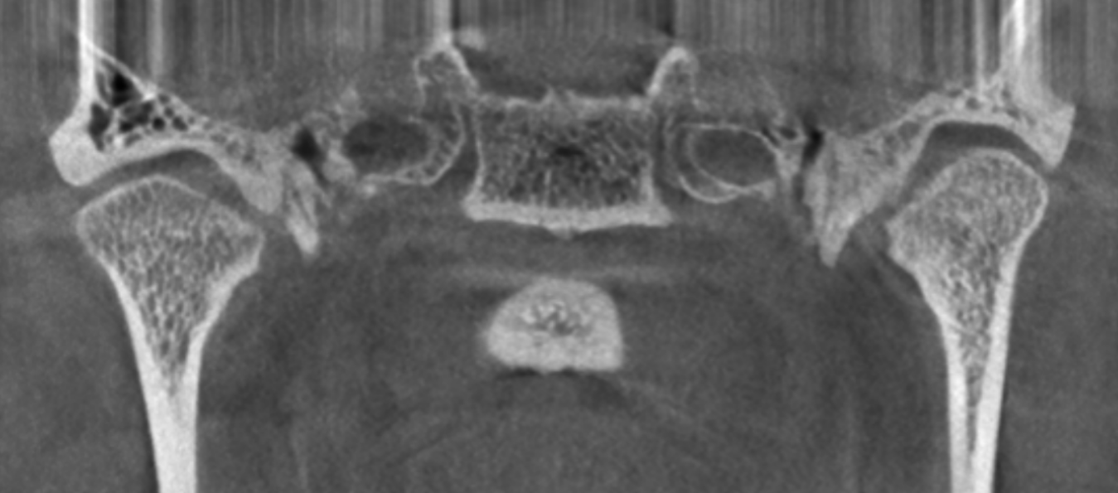

RIGHT TEMPOROMANDIBULAR JOINT

At rest:
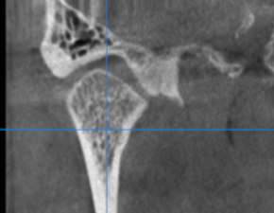
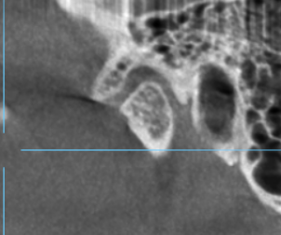

LEFT TEMPOROMANDIBULAR JOINT

At rest:
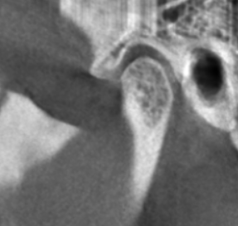
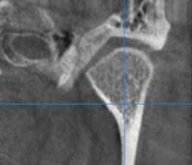

Right TMJ during mouth opening:
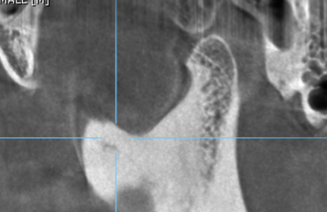

Left TMJ during mouth opening:
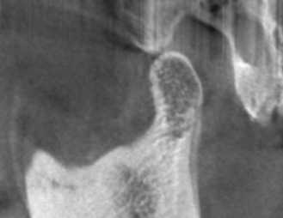
**** End of report ****

